What can I do to help my child when the Corona Virus (Covid 19) is causing anxieties?
Currently the nation is experiencing a situation we have not seen before. It is causing us all to change our normal routines and is causing many children with autism anxieties. These anxieties may be because of:
- Change of routines- schools may be closed, family members may not be visiting, having to stay in and not do our usual activities
- News stories, social media posts are heightening anxieties with stories of illnesses, deaths, closures, cancellations and lots of uncertainty
- Supermarket shortages may mean we cannot access the normal supplies our children may prefer
- Personal Hygiene changes may be causing sensory sensitivities which a child may not like, or their anxieties may be causing them to over wash
10 Top Tips to Help Your Child
- Talk to them about what they understand- this would be a good time to check the internet on the facts with them as the information is changing daily. Talk to them about what it is,
https://www.nhs.uk/conditions/coronavirus-covid-19/ is being updated daily. Be aware of websites that may not be factually correct.
There are videos to explain to young children what it is on BBC Newsround. https://www.bbc.co.uk/newsround/51887051
- Turn off the News on the TV in front of your child, and Limit access to social media- There is lots of speculation on these media forms which can cause high anxiety. Limit internet access for your child and avoid uncertain conversations in front of them. Follow number 1 guidelines on the information your child is accessing.
- Teach Hygiene- Schools have been teaching all children good hygiene to protect everyone from Covid 19. As parents we can do this at home too. Below is a social story which can help children with autism to understand the virus and how children can help themselves
- Provide Predictability/structure and routines- Children with autism need lots of predictability, structure and routines. Visual timetables (pictures, checklist, symbols), diaries or calendars can help with this. Discuss with your child each morning what is going to happen that day, who they are going to be with, what activities they can do and when.
- Keep them busy with fun activities- use this time to do some fun activities at home that you may not normally have the time to do. Teaching some life skills- cooking, get them to help with housework, reading, etc. Check with your child’s school of websites that can be used for fun learning activities, home work or other learning options.
- Teach calming strategies- many children with autism struggle to self-regulate and relax. Explore different options to help to reduce anxieties- yoga, breathing exercises, relaxing music, sensory games, meditation, video clips. Every child is different, and you know your child best. There are a selection of You Tube clips on many activities, but remember to check them out yourself first before showing your child.
- Reassure them
- Keep it simple and factual- avoid using too much language, and terms your child may not understand.
- Food Limitations- with supermarket shortages you may not be able to buy a good stock of your child’s food options. It would be good to have a daily/weekly menu which you discuss with your child daily/weekly by giving the options that you know you have or can get easily.
- Call/Video call/ or write to relatives- If your child is missing a favourite person or worried about a relative, explore ways to keep in touch to reassure your child they are ok.

Social Story example
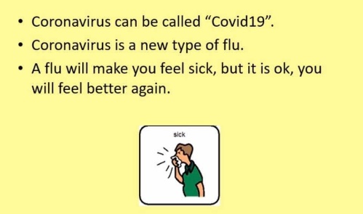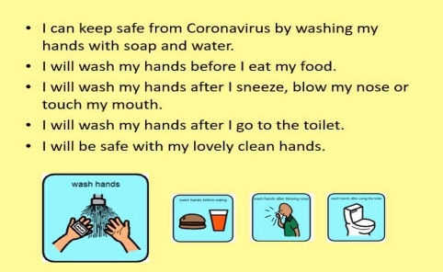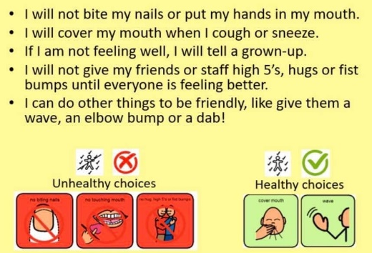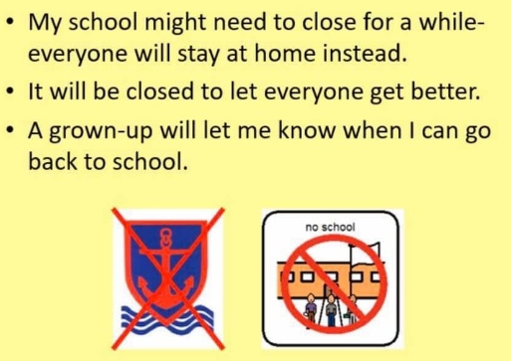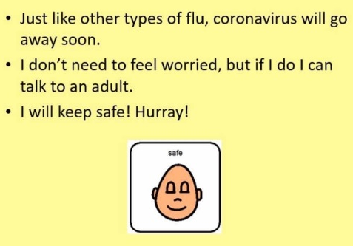
Timetable Example
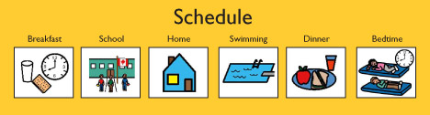

Useful Websites

- National Autistic Society – guidance and helpline for parents’, young people and staff:
https://www.autism.org.uk/services/nas-schools/vanguard/news/2020/march/coronavirus-(covid-19)-advice.aspx

- Mencap - Easy Read guide to Coronavirus: https://www.mencap.org.uk/sites/default/files/2020-03/Information%20about%20Coronavirus%20ER%20SS2.pdf

- Place2Be – Guide to helping parents answer questions from their children and to support family wellbeing: https://www.place2be.org.uk/about-us/news-and-blogs/2020/march/coronavirus-information-for-children/

- Young Minds - Talking to your child about Coronavirus and 10 tips from their Parents Helpline to support family wellbeing: https://youngminds.org.uk/blog/talking-to-your-child-about-coronavirus/

- Carers UK - Guidance for carers: https://www.carersuk.org/help-and-advice/health/looking-after-your-health/coronavirus-covid-19

- Covibook – an interactive resource designed to support and reassure children aged 7 and under, designed to help children explain and draw the emotions that they might be experiencing during the pandemic: https://www.mindheart.co/descargables

- Amaze - information pack for parents https://amazesussex.org.uk/faqs-about-the-coronavirus-for-parent-carers-of-children-with-send-brighton-hove/

