PE with Joe wicks morning workout
Every morning Monday – Friday at 9.00am Joe Wicks is going to do a workout for all ages of children from 09.00am-09.30am on his YouTube channel, on his YouTube channel you can find other workout videos.
https://www.youtube.com/results?search_query=the+body+coach&safe=true
For more ideas on workouts & activities you can do from home please check out the following websites: https://www.sportengland.org/stayinworkout
https://primarypeplanning.com/ (If you search for this company on Facebook they have some good videos of activities you can do at home with limited equipment).
More Joe Wicks Kids Work Out https://www.youtube.com/watch?v=d3LPrhI0v-w
Personal Challenges –
The personal challenge will involve you doing activities for 40 seconds without stopping .Then repeating this every day to beat your score. How many can you do?
Week 1 Activities | Days of the week – Score
 | M | T | W | T | F
Jumping jacks
Frog jumps

Week 2 Activities | Days of the week – Score
 | M | T | W | T | F
Star Jumps
Hops

Week 3 Activities | Days of the week – Score
Can you last 40 seconds? | M | T | W | T | F
Jogging on the spot
Skipping on the spot

Week 4 Activities | Days of the week – Score
 | M | T | W | T | F
March on the spot
Jump on the spot

Useful links for active activities –
Cosmic kids - https://www.cosmickids.com
Just dance kids - https://www.youtube.com/results?search_query=just+dance+kids&safe=true
Premier league –Solve , Shoot and Score - https://plprimarystars.com/for-families/play-game
Exercise games and indoor activities to get kids moving
Obstacle course | Create a furniture assault course or take chalk and make a course outside in the garden. Add in specific mental or physical challenges to keep them guessing.
Wheelbarrow, crab, and bear-walk races: | Create races doing either a wheelbarrow race, crab-walking race or bear walking race.
Animal races | Hop like a bunny or frog; squat and waddle like a duck; stomp like an elephant.
Balloon ball | There are endless ways to play with balloons indoors. Try to keep it off the ground or just play catch. Mix it up with balloon tennis!
Follow the leader | Add to the workout with energetic movements such as jumping, stomping, and squatting.
Just dance kids dance party | Just dance kids on youtube and ask the children to attempt to copy each movement.
Freeze dance | When the music stops, freeze in your pose and hold it until the music begins again.
Scavenger hunt | Write up clues and hide them around the house. Kids can race to find each clue for a small prize at the end.
Jumping jacks | Simple but good for coordination and they get your heart going. See how many you can do in a minute.
Parachute | Each child takes an end of the parachute or sheet and fans it upward while one of you runs underneath. This could be done by using a sheet or a towel. You could also add some balls on the top or a beanbag to attempt to get it off the parachute.
Clean-up race | Set a timer or put on a song to see who can tidy the room the fastest
Yoga | Cosmic kids on youtube have a large selection for the children to access.

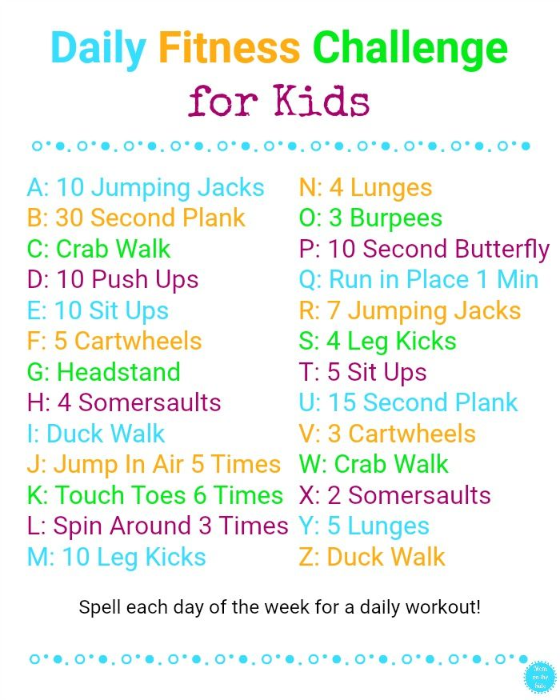
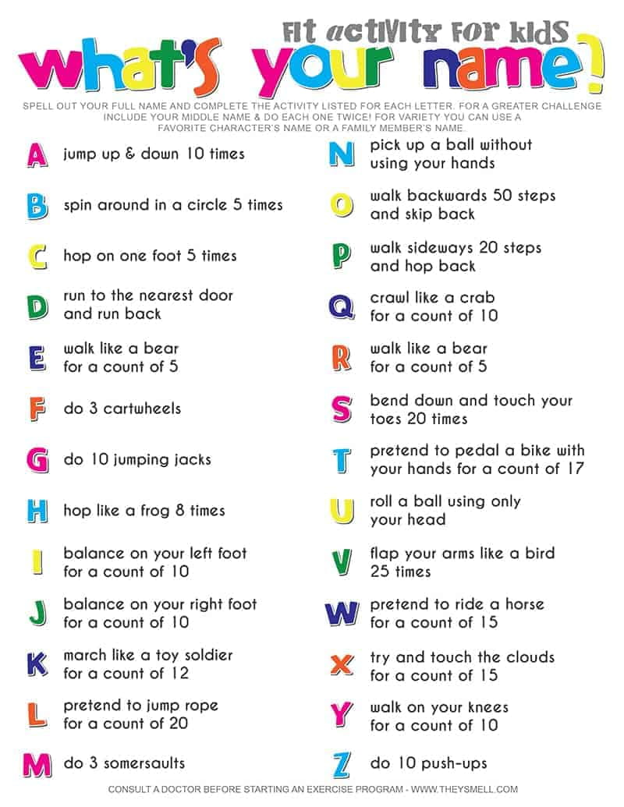
PE challenges- Do one daily

