PE with Joe wicks morning workout
Every morning Monday – Friday at 9.00am Joe Wicks is going to do a workout for all ages of children from 09.00am-09.30am on his YouTube channel, on his YouTube channel you can find other workout videos.
https://www.youtube.com/results?search_query=the+body+coach&safe=true
For more ideas on workouts & activities you can do from home please check out the following websites: https://www.sportengland.org/stayinworkout
https://primarypeplanning.com/ (If you search for this company on Facebook they have some good videos of activities you can do at home with limited equipment).
More Joe Wicks Kids Work Out https://www.youtube.com/watch?v=d3LPrhI0v-w

Personal Challenges
Personal challenge will involve you doing activities to reach your goal at the end of the week. You will give yourself 1 minute every day to beat your score.
Week 1 Activities | Days of the week – Score
 | M | T | W | T | F
Burpees
Mountain climbers

Week 2 Activities | Days of the week – Score
 | M | T | W | T | F
Leg raises
Squats

Week 3 Activities | Days of the week – Score
 | M | T | W | T | F
Butterfly kicks
Jumping Jacks

Week 4 Activities | Days of the week – Score
 | M | T | W | T | F
High knees
Frog Jumps

PE Fitness games -
- Squat Relay: Line up on opposite sides of the room, facing each other. On "go," all kids run toward the centre of the room and meet in the middle. They do three squats, giving each other an elbow touches with both elbow in between each rep. Then they return to the starting point and repeat. The focus is on the elbow touches and the social interaction. If you have a more than four kids doing it, you could have the lines shift sideways between reps so kids meet a different friend in the middle of the room each time.
- Corners: Divide kids up so that they each have a home corner. Then have them run around the room in a circle, on your cue, they return to their home corner and do a few easy exercises (say, 5 jumping jacks or one 30-second plank). Let kids decide what exercises to do in each corner to give them ownership over their game.
12 At-Home Workouts to Do With Your Kids
Aim for 40 seconds of work, followed by 10 seconds of rest. Alternate through the activities above and aim for a 30-minute workout.

1. Mountain Climbers | Get into a push-up position and then alternate bringing your knee to your elbow. You can do same side connections or crisscross. The idea is to move fast and work up a sweat.
2. Bear Crawls | Palms and feet flat on the floor, arch your back so that you look like a momma bear. Race your kids across the room. Add some fun by having a competition!
3. Star Jumps | Kids love these! Stand tall and then explosively jump into the air, expanding your legs and your arms so that you look like a large “X” in the air. At the height of the jump, be sure to exclaim, “I’m a STAR!”
4. Push Ups | Just be sure your hands are in line with your pectorals. If you want to make it harder, try for push–up claps, diamond push-ups, or “Y” wide push-ups.
5. Sit Ups | Another classic. Feel free to tuck your toes under the sofa or coffee table if you need a bit of support, or, ask your kids to hold your feet and vice versa.
6. Burpees | Who is up for the challenge? Start with a jump up, then drop to a plank, add a push-up, and then jump back up. It should be one fluid motion and try to not pause between repetitions. Make it a bit easier by opting out of the push up if you need to.
7. Squats | To do this one, stand with your feet shoulder’s width apart, and do deep knee bends. Make sure keep your knees behind your toes and your arms out straight.
8. Leg Raises | Lay on your side or on your back and with lift your legs without bending at the knee. Try to hold at the top. This works your lower abdominals, but be careful to not let your lower back arch.
9. Lunges | Step forward and bend your front knee to a 90-degree angle. The goal is to have your back knee touch the ground without letting your front knee extend past your toes.
10. Planks | Elbows on the floor and balanced on your tiptoes, go eye-to-eye and see who can last the longest.
11. Jumping Jacks | With many variations to the classics, this one can go from arms out like a star jump and legs out when jumping. From standard to reverse, this one will keep your heart rate up.
12. Butterfly Kicks | Lay flat on your back, and extend your legs straight out. Imagine a swimmer, and begin to flutter kick your legs without bending at the knee. Start with your feet high off the floor, as the move gets more difficult the closer the action is to the floor.
13. Crabs walks | Sit with your knees bent and feet flat on the ground; place palms on the ground behind you. Lift hips a few inches and walk forward on your hands and feet like a crab, then walk backward.
14. Side leg raises | Lie on one side, with your feet and hips stacked; prop yourself up on your forearm. Align shoulder over elbow. Lift your top leg straight up, keeping foot parallel with the ground and flexing your toes; pause at top, then lower.

The Home Bleep Test
Choose an area where you can run back and forth (The garden, a hallway, your bedroom). You must complete one length before the bleep. The further you get, the quicker the bleeps sound.
See how far you can last into the bleep test without stopping or without missing a bleep. https://www.youtube.com/watch?v=e0U_yQITBks

Bottle Flip challenge –
Water bottle flipping is the latest craze activity and challenge that involves throwing a plastic water bottle! Partially fill a bottle with liquid, and throw into the air so that it rotates, in an attempt to land it upright on its base or cap.
Get flippin' with this challenging game – How many can you land?
Sock Ball
Roll a pair of socks into a ball. Can you throw this ball into a shoe? How many can you score in 2 minutes? Too easy? Can you do it from further away? Too hard? Can you use a bigger target? What about a washing basket?

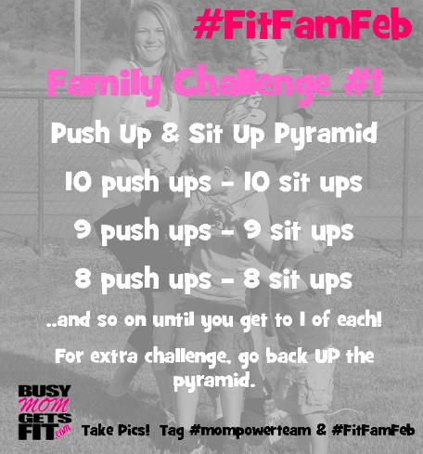
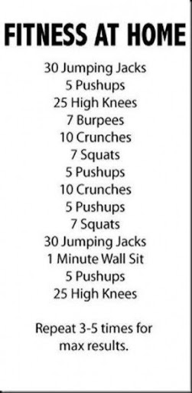
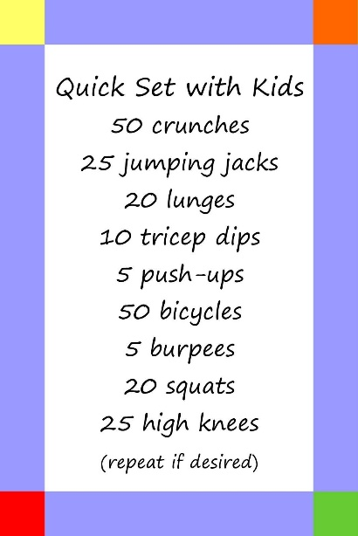
.PE Challenges

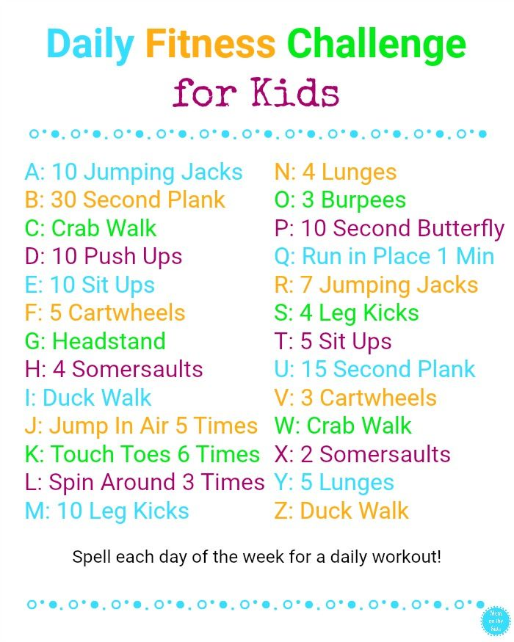
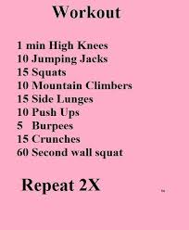

Choose one challenge daily.

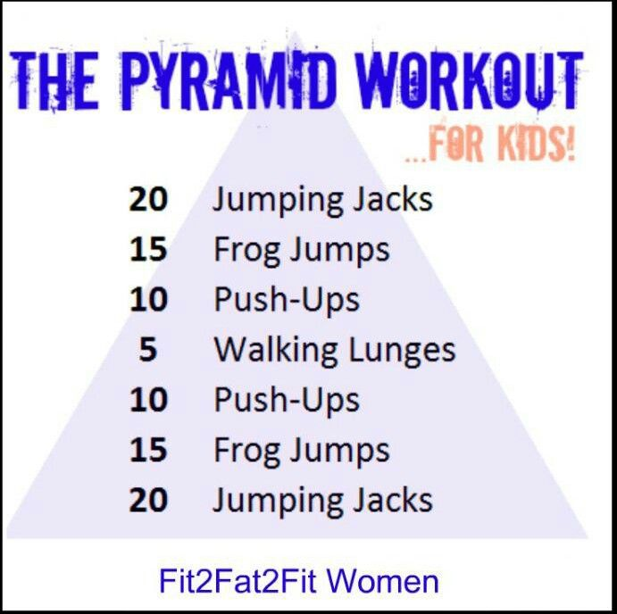
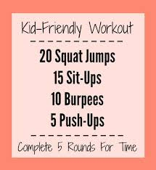
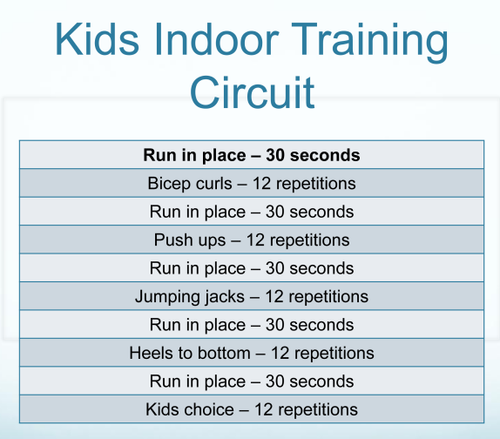

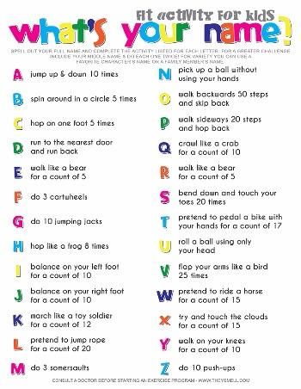
Online Challenges -
http://www.fitnessforkidschallenge.com/challengeactivities

